Overview and Getting Started

Introduction
This website application is a reviewing resource for you to use. It will allow you to solve exercises with questions about a solution to the programming assignments you have previously turned in.

Log In
To access the website application, navigate to https://helen.cumberland.vanderbilt.edu. You will immediately be prompted to log in with your VUNETID/Email Address and corresponding password through the Vanderbilt University authentication system.

Layout
The website is designed to work on both desktop and mobile browsers. However, it is highly recommended that you open it on desktop for a better viewing experience.
The navigation bar will be located on the left side for desktop browsers and hidden under a toggle button for mobile browsers. There are 3 pages total for student accounts:
- Dashboard: the user’s home page.
- Chapters: website pages with details and exercises for each chapter.
- Settings: allow users to view their information and change their application theme.

Exercises
To access your exercises to complete, there are two different pages you can open an exercise from: the Dashboard page or the Chapters page.

Dashboard
The Dashboard is your home page. You will be able to see any assigned exercises for the next week as well as their corresponding due dates. Any incomplete exercises will have a “Start” button which will change into a “View” button upon completion.

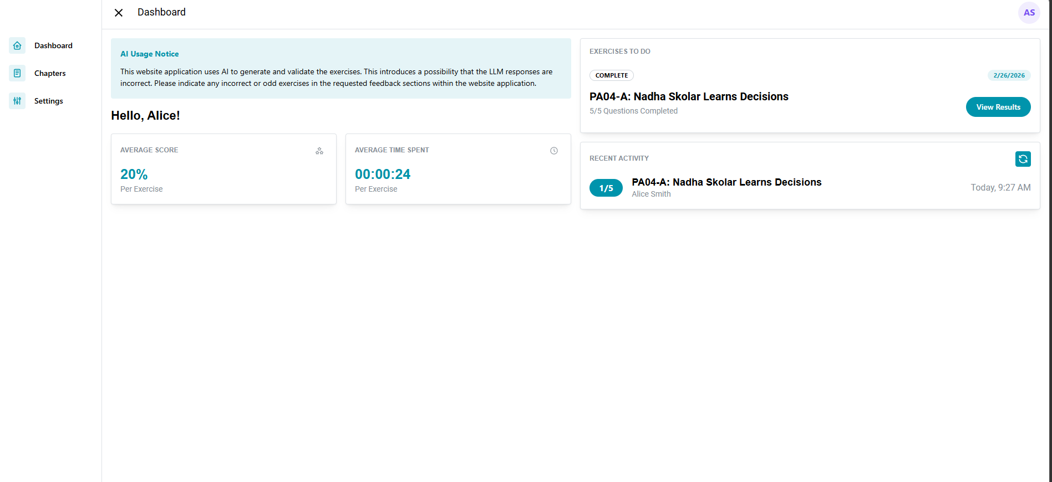

Chapters
Each chapter will have a webpage where all the exercises for that chapter are shown. Similar to the Dashboard, you can open incomplete exercises or view results for complete exercises. Some exercises may be “Locked” which means they are unavailable to you until a later date.

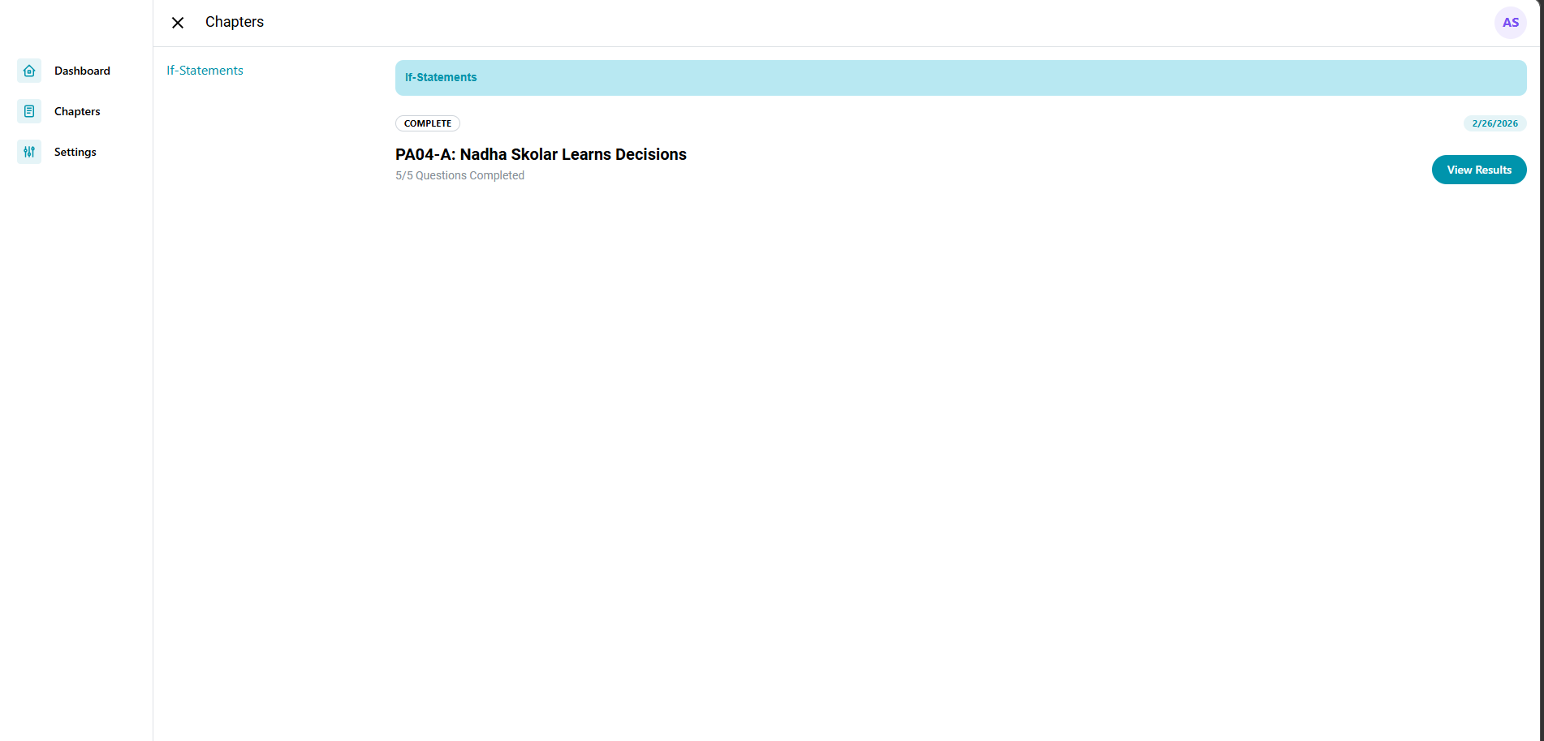

Not Started/In Progress Exercises
Upon clicking the “Start” button on either the Dashboard or Chapters page, a popup will appear with the exercise you should complete. You will be provided with a question about a block of code from a solution to a previous programming assignment. You can click on an answer to select it; if you change your mind, you can select another answer before submitting.
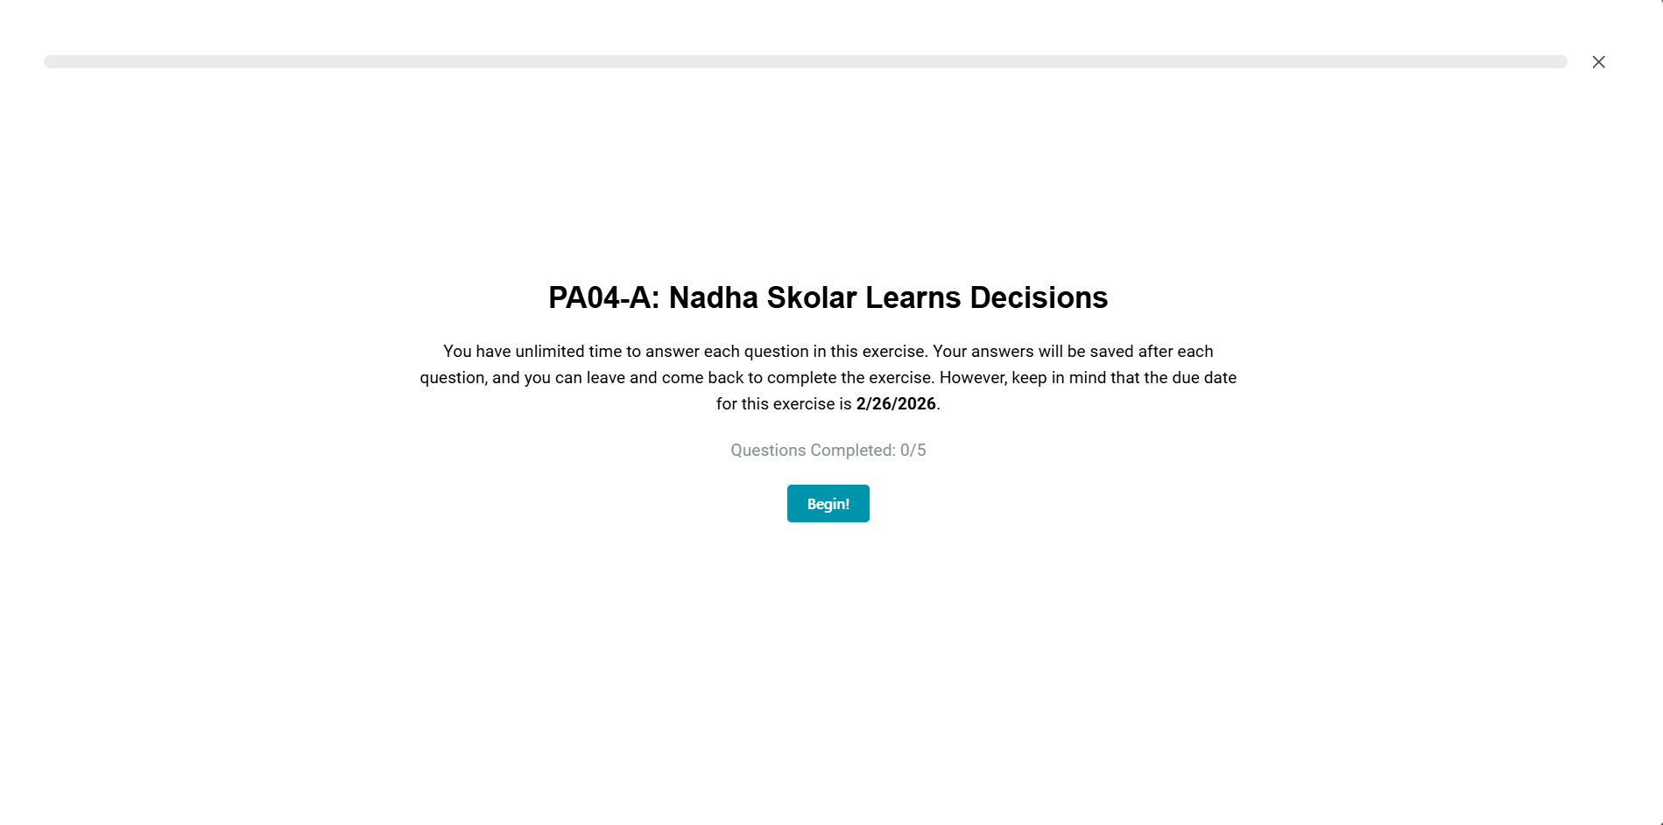

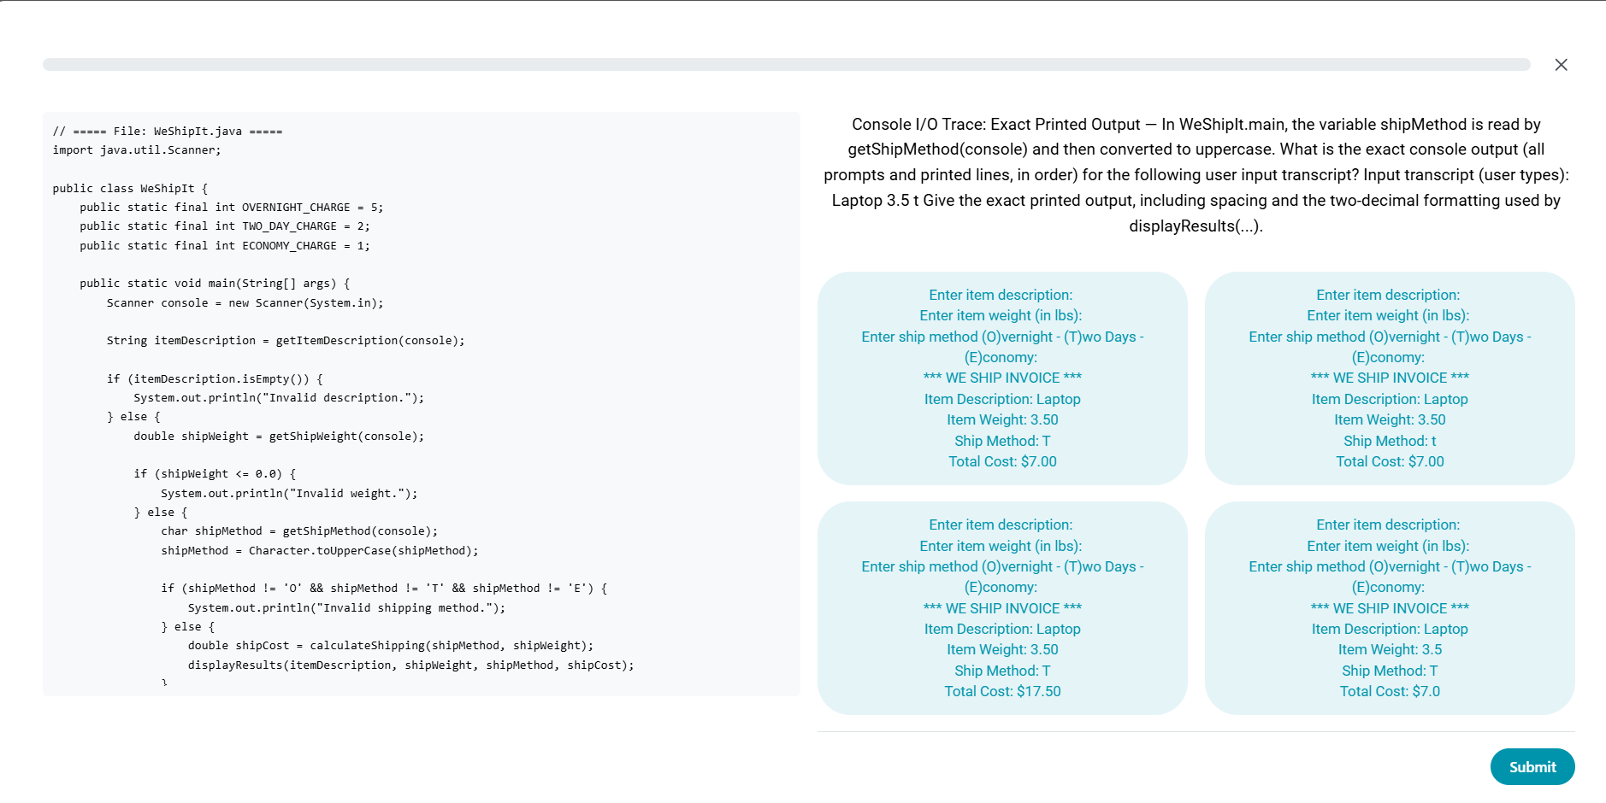
Once you’ve determined your final answer, you can submit your initial answer. If it is correct, you will see a checkmark with an explanation why it was correct. You can indicate if the code itself seemed unreasonable for a CS 1101 student to write or send an email if the question itself was incorrect. Additionally, the question will prompt you to give some quick ratings regarding the quality of the question; once these are answered, the continue button will light up and allow you to move onto the next question.
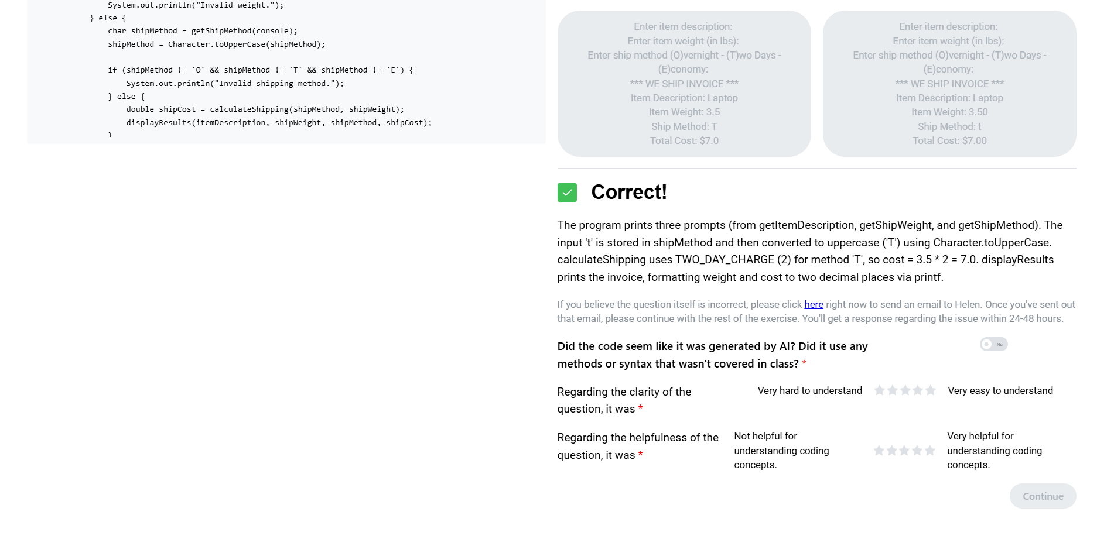
If your answer was incorrect, you will see an X and a hint for the correct answer. You cannot move onto the next question until you eventually submit the correct answer. You care able to send an email to Helen if you believe the question itself is faulty; she will address your issue within 24-48 hours.
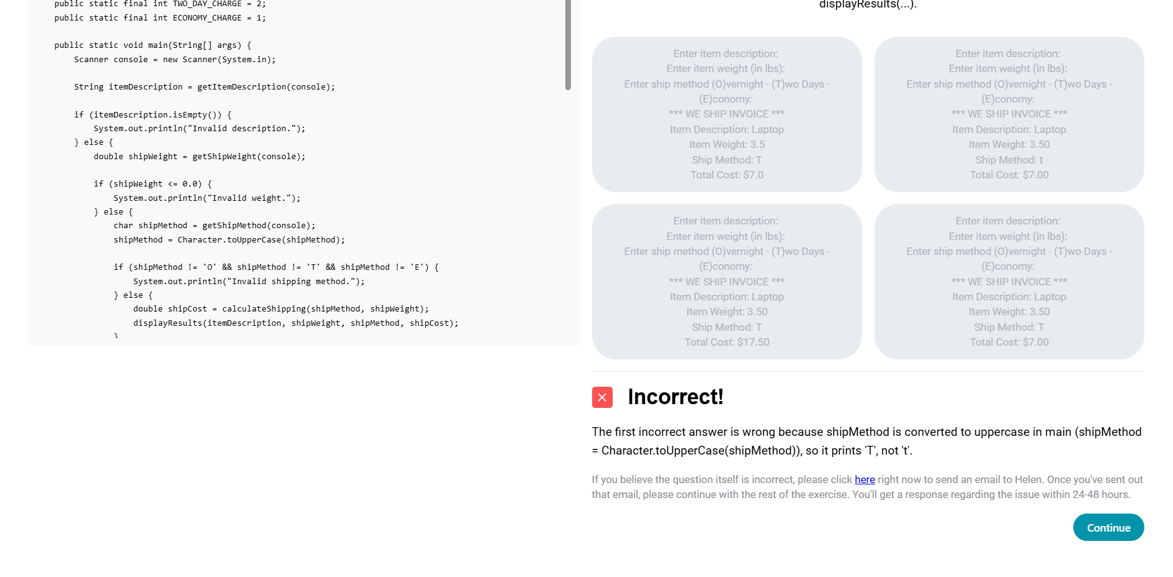
Your answers are saved after every response. You can exit the exercise and come back, but be sure to do so before the exercise is due. Once the last question has been correctly answered, you will be given a summary of the exercise questions you answered. To mark the exercise as complete, you MUST click the “Mark Complete and Exit” button to count it towards your extra credit.
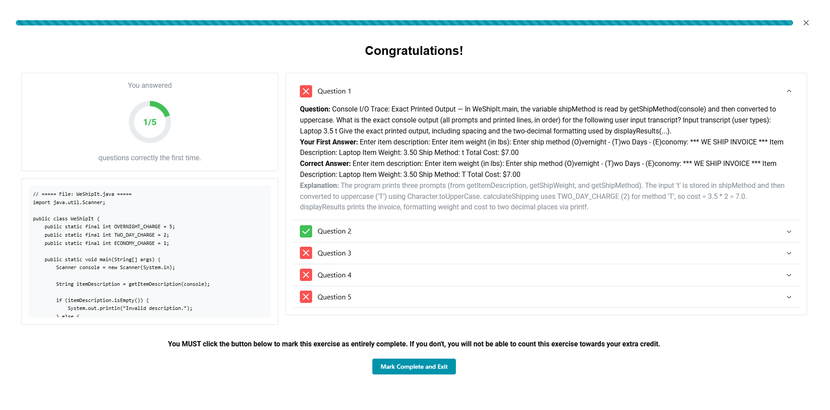

Completed Exercises
Upon clicking the “View” button on either the Chapters or Dashboard page, a popup will appear with details regarding the exercise you have previously completed. You will be able to see your initial answers to each question, whether you were correct, and the explanation for the correct answer. The aggregate score you see is only reflective of your initial answers to the question.
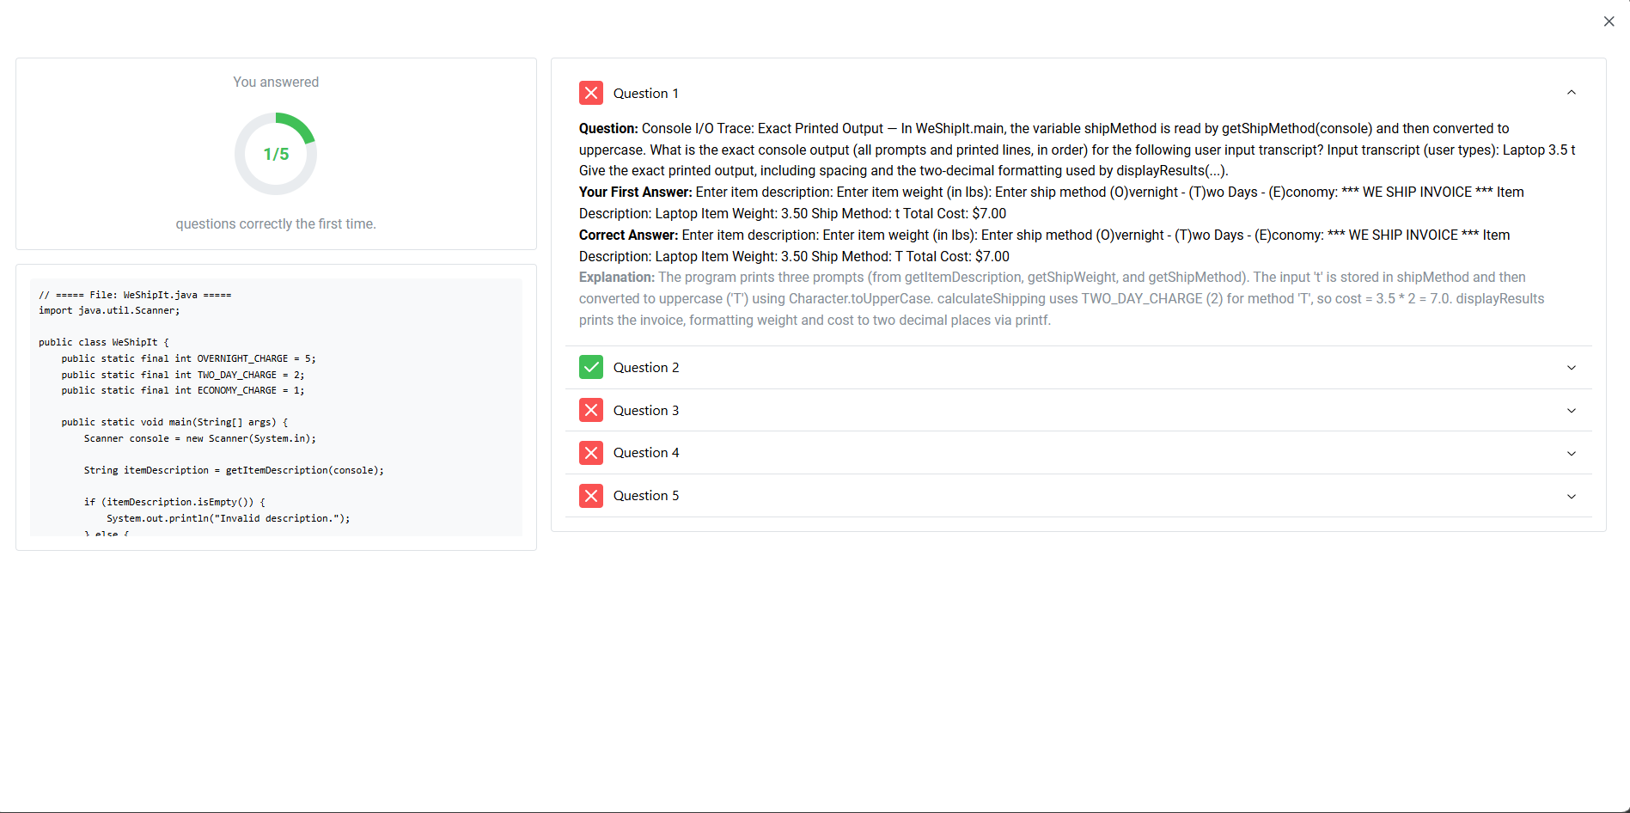

Feedback
For some chapters, you may be asked to give some feedback on the overall experience. This is accessible similar to an Exercise. These are due at the same time as the corresponding exercises.
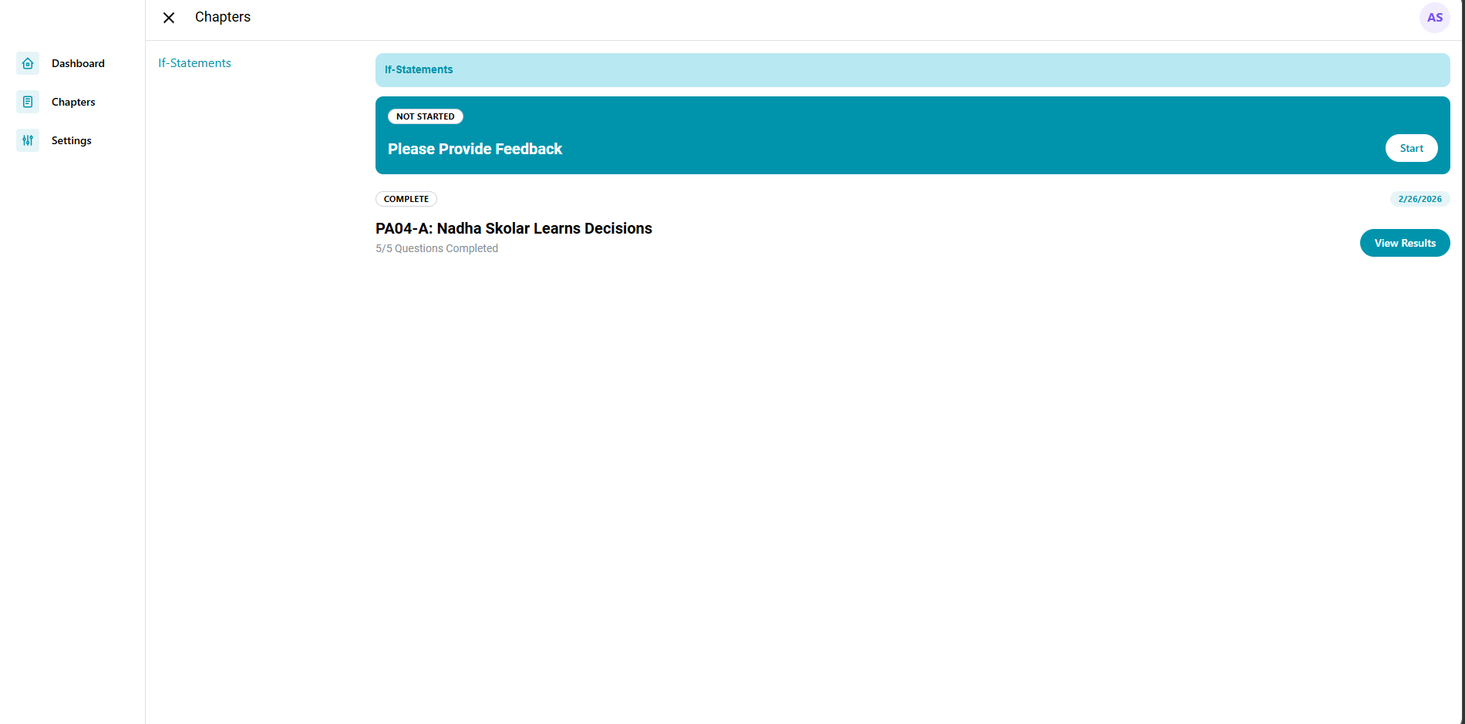
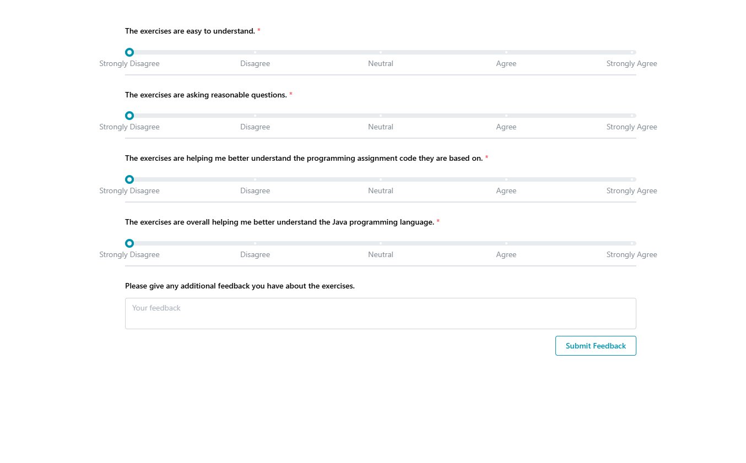

Settings
You can view your name and email from the Profile tab on the Settings page. These are values directly retrieved from your Vanderbilt University account. If it is incorrect in any way, you will likely need to contact VUIT to check that your Vanderbilt University account credentials are correct. You can also change the theme of the website application on the Settings page.

Contact
If you have any questions or encounter any problems with the website application. Please send an email to helen.wu@vanderbilt.edu, not your immediate instructor. We will try to resolve any issues as soon as possible.

